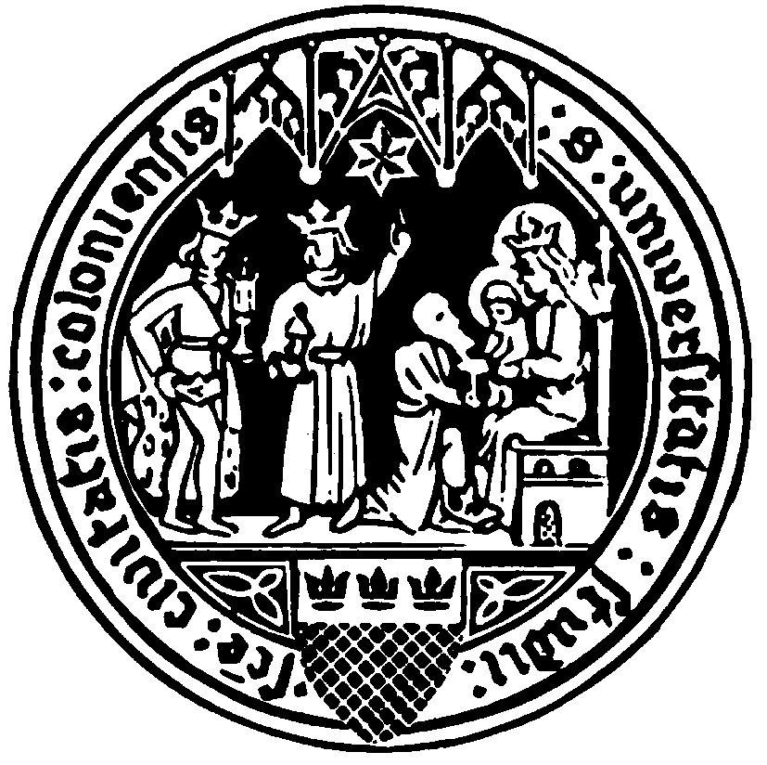
International Master of Environmental Sciences

Prof. Dr. Kirk W. Junker (Chair of IMES Examination Committee)
Chair, US-American Law, University of Cologne
Aachener Str. 201, 50931, Cologne, Germany
Tel: +49 (0) 221 16821594
Email: Imes-info@uni-koeln.de

Universität zu Köln – Chair of US-American Law – Prof. Dr. Kirk W. Junker

Start of Master Thesis

Dear ☐Mr./☐Ms./☐Mx. Click or tap here to enter text.
The examination board of the International Master of Environmental Sciences program at the University of Cologne hereby issues the following topic for your Master thesis:
Click or tap here to enter text. to be carried out under the supervision of Click or tap here to enter text.
The thesis is issued as of Click or tap to enter a date.. Please note that you have to also submit an electronic version of the thesis (in .doc or .docx format) for further investigation on plagiarism. By signing this document, you agree to the conditions of study, acknowledging a period of six months to complete your thesis.

____________________
Signature, IMES Student

Best regards and good luck,

____________________ ____________________

Prof. Dr. Kirk W. Junker
Chair, IMES Examination Committee Name & Signature, Thesis Supervisor

